- Create a new component
- Sign in to make.powerapps.com.
- Select Apps and select Canvas app from blank.
- Provide an app name, select any layout, and then select Create.
- In the Tree View, select Components and then select New component to create a new component.
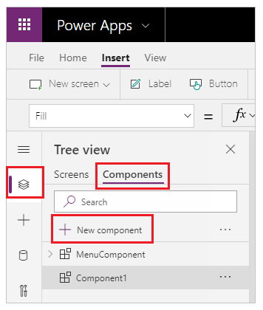
- Select the new component in the left navigation, select the ellipsis (...), and then select Rename. Type or paste the name as MenuComponent.
- In the right-hand pane, set the component's width as 150 and its height as 250, and then select New custom property. You can also set the height and width to any other value as appropriate.
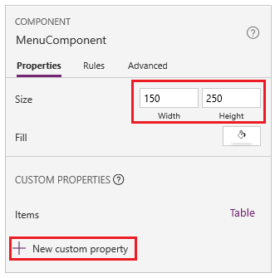
- In the Display name, Property name, and Description boxes, type or paste text as Items.
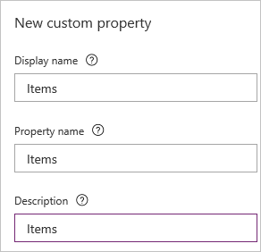
Don't include spaces in property name because you'll refer to the component by this name when you write a formula. For example, ComponentName.PropertyName.
The display name appears on the Properties tab of the right-hand pane if you select the component. A descriptive display name helps you and other makers understand the purpose of this property. The Description appears in a tooltip if you hover over the display name of this property in the Properties tab.
- In the Data type list, select Table, and then select Create.
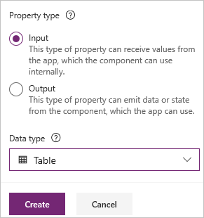
The Items property is set to a default value based on the data type that you specified. You can set it to a value that suits your needs. If you specified a data type of Table or Record, you might want to change the value of the Items property to match the data schema that you want to input to the component. In this case, you'll change it to a list of strings.
You can set the property's value in the formula bar if you select the name of the property on the Properties tab of the right-hand pane.
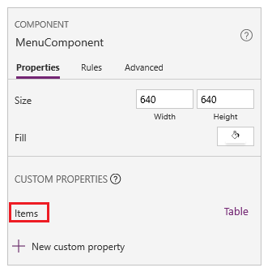
As the next graphic shows, you can also edit the property's value on the Advanced tab of the right-hand pane.
- Set the component's Items property to this formula:
Power AppsCopy
Table({Item:"SampleText"})
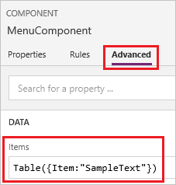
- In the component, insert a blank vertical Gallery control and select Layout on the property pane as Title.
- Make sure that the property list shows the Items property (as it does by default). And then set the value of that property to this expression:
Power AppsCopy
MenuComponent.Items
This way, the Items property of the Gallery control reads and depends on the Items input property of the component.
- Optional - set the Gallery control's BorderThickness property to 1 and its TemplateSize property to 50. You can also update values for border thickness and template size to any other value as appropriate.
- Add component to a screen
Next, you'll add the component to a screen and specify a table of strings for the component to show.
- In the left navigation bar, select the list of screens, and then select the default screen.
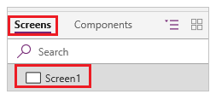
- On the Insert tab, open the Components menu, and then select MenuComponent.
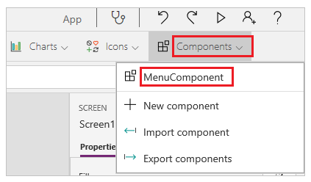
The new component is named MenuComponent_1 by default.
- Set the Items property of MenuComponent_1 to this formula:
Power AppsCopy
Table({Item:"Home"}, {Item:"Admin"}, {Item:"About"}, {Item:"Help"})
This instance resembles this graphic, but you can customize the text and other properties of each instance.
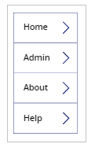
- Create and use output property
So far, you've created a component and added it to an app. Next, you'll create an output property that reflects the item that the user selects in the menu.
- Open the list of components, and then select MenuComponent.
- In the right-hand pane, select the Properties tab, and then select New custom property.
- In the Display name, Property name, and Description boxes, type or paste Selected.
- Under Property type, select Output, and then select Create.
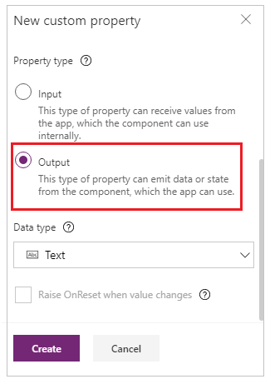
- On the Advanced tab, set the value of the Selected property to this expression, adjusting the numeral in the gallery name if necessary:
Power AppsCopy
Gallery1.Selected.Item
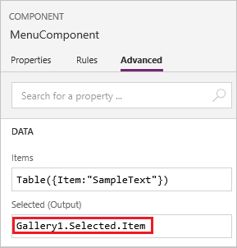
- On the default screen of the app, add a label, and set its Text property to this expression, adjusting the numeral in the component name if necessary:
Power AppsCopy
MenuComponent_1.Selected
MenuComponent_1 is the default name of an instance, not the name of the component definition. You can rename any instance.
- While holding down the Alt key, select each item in the menu.
The Label control reflects the menu item that you selected most recently.
- Known limitations
- You can't save data sources, forms, and data tables with components.
- Collections in components are not supported.
- You can't insert a component into a gallery or a form.
- A master instance of a component is a local master and scoped to the app. If you change a master instance, only copies of the component within the app will reflect the change. Copies in other apps will remain the same unless you import the component library again. All master instances in those apps will be automatically detected and updated.
- You can't package media files when you import a component.
- Components don't support the UpdateContext function, but you can create and update variables in a component by using the Set function. The scope of these variables is limited to the component, but you can access them from outside the component through custom output properties.

